EXPERIMENT NO: 2

Name: Mukhilan. S
Reg No: 192512196
Subject: Analog and Digital Communications
Code: ECA-0803

Program:
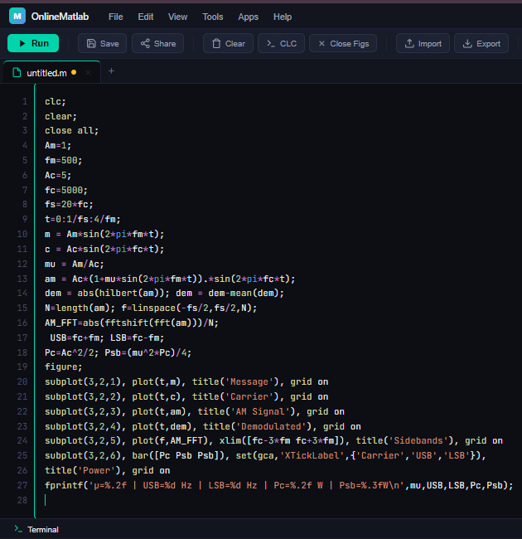
Output:
